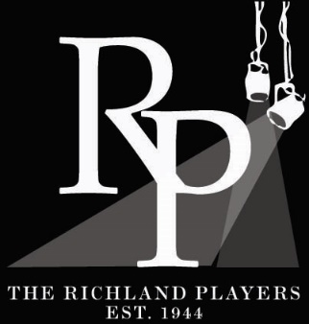 The Richland Players Application for Directors 2021-2022 Season
All applications due September 20th, 2021
Email to: spyder.isaacson@richlandplayers.org (Richland Players Artistic Committee Chair)
You can also mail to: Richland Players Theatre, P.O. BOX 603, Richland, WA 99352.
Name: Phone:

E-mail:
Plays (in order of preference) you are applying to direct: ______________________________________________________________________________ ______________________________________________________________________________ ______________________________________________________________________________
Do you have any foreseen conflicts or prior commitments that might interfere with the production of these plays in their currently proposed time slots? ______________________________________________________________________________ ______________________________________________________________________________ ______________________________________________________________________________
All Directors are expected to follow our Reopening Policy as listed on our website. https://www.richlandplayers.org/reopening-policy
Please voluntarily disclose if you have been vaccinated against COVID-19.
Yes ____ No ____ Decline to Answer ___
Please attach a separate sheet answering the following questions. Attach answers for EACH play you are applying for:
- What component of our Mission, Vision and Values resonates with you and how you may direct this play and/or what components of our Mission, Vision, and Values are you able to highlight while directing this play?

Mission Statement:
Forging an inclusive outlet for artistic expression and growth.
Vision Statement:
Community Theatre for all. By the people, for the people. Because theatre matters.
Values Statement
- Inspiration – Theatre spurs exploration and discovery.
- Community – A second home for artistic collaboration.
- Inclusiveness – Without diversity theatre neither inspires nor educates.
- Innovation & Creativity – Enlightenment through unique art.
- Excellence – It is our commitment to our community and the stories we tell.

- Please briefly include a list of your theater experience or any educational experience you have that qualifies you to direct at the Richland Players.

- Why are you interested in Directing this play?

- What challenges do you foresee with this production and how to propose to address them?

- What opportunities do you foresee with this production and how would you hope to capitalize on them?

- What is your general artistic vision for this production and what support staff are you likely able to secure to help you successfully obtain this vision?

- In general, The Richland Players will not allow modifications to the script as it is intended to be performed per our license agreements and as written by the playwright. Any proposed modifications must be received with this application in order to be considered and is subject to approval by both the Richland Players and the agent that holds the copyright. Please list any such proposed modifications if applicable.

Thank you for your interest in working with The Richland Players. We look forward to hearing from you.

The Prude’s Progress by Jerome K. Jerome and Eden Phillpotts
Main Season Show
March 4-6, 11-13, 18-20
Script: https://www.gutenberg.org/files/47559/47559-8.txt

“A comedy in three (3) acts.”

Fools by Neil Simon
Main Season Show
June 24-26, July 1-3, 8-10
Scripts: Can check out at The Richland Public Library, 955 Northgate Drive, Richland, WA 99352

“Leon Tolchinsky is ecstatic. He’s landed a terrific teaching job in an idyllic Russian hamlet. When he arrives, he finds people sweeping dust from the stoops back into their houses and people milking upside down to get more cream. The town has been cursed with Chronic Stupidity for two hundred years (200), and Leon’s job is to break the curse. No one tells him that if he stays over twenty-four (24) hours and fails to break the curse, he to becomes Stupid. But he has fallen in love with a girl so Stupid that she has only recently learned how to sit down.”

